Safety Data Sheet
– (in compliance with Regulation (EC) 1907/2006, Regulation (EC) 1272/2008 and Regulation (EC) 2020/878).
-According to REACH Regulation (EC) No 1907/2006, as amended by UK REACH Regulations SI 2019/758

1. IDENTIFICATION OF THE SUBSTANCE/MIXTURE AND OF THE COMPANY/UNDERTAKING

1.1 Product Identifier:
Trade Name (as labeled):

FEDERICI BRANDS – COLOR WOW DRY SHAMPOO

1.2 Relevant Identified Uses of the Substance or Mixture and Uses Advised Against:

Product use: Hair care
Restrictions on use: None Identified

  - Details of the Supplier of the Safety Data Sheet:

-European Union (EU) –
Manufacturer/Supplier Name: FBRP Limited
Manufacturer/Supplier Address: 9/10 Fenian Street
Dublin 2
D02 RX24
Ireland
-United Kingdom (UK)–
Manufacturer/Supplier Name: Federici Brands Ltd.
Manufacturer/Supplier Address: 22 Chancery Lane
London WC2A 1LS
United Kingdom
-United States (US) -
Manufacturer/Supplier Name: Federici Brands LLC
Manufacturer/Supplier Address: 195 Danbury Road,
Davenport Building, Suite 300 Wilton, CT 06897

Manufacturer/Supplier Telephone Number:

EU - +44 (0) 207 313 2360
UK -
US - (203) 762-7667
Email address:

1.4 Emergency Telephone Number:
EU –
UK -
US - (844) 495-5969
2. HAZARDS IDENTIFICATION

2.1 Classification of the Substance or Mixture:

Classification:
Physical | Environmental | Health
Extremely Flammable Aerosol Category 1 | Not Hazardous | Eye Irritant Category 2A

2.2 Label Elements:

Danger!
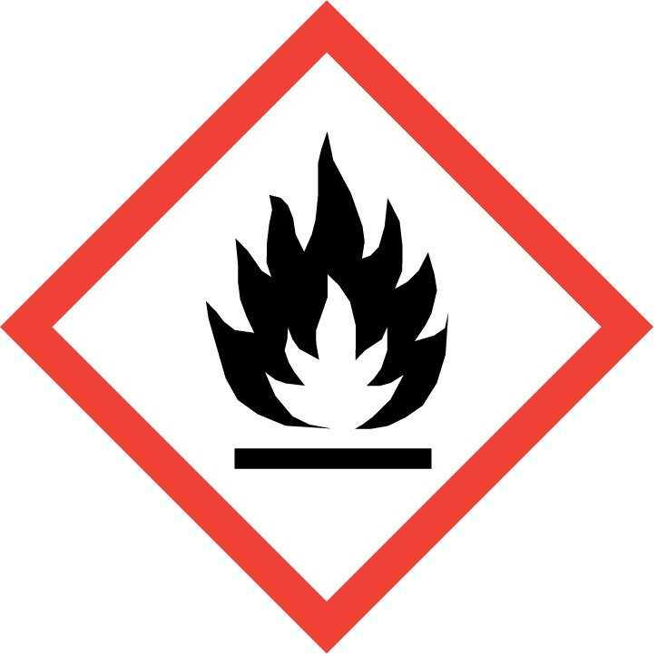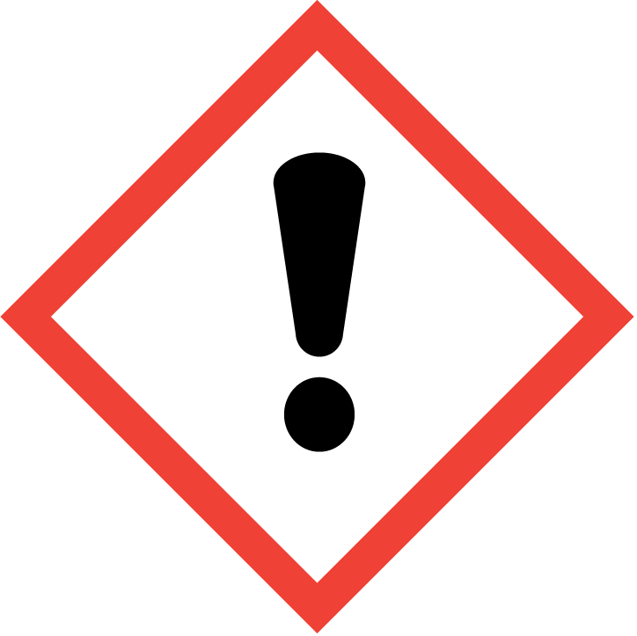

Contains: Ethanol

Statements of Hazard | Precautionary Phrases
H222 Extremely flammable aerosol.  H229 Pressurized container: may burst if heated.  H319 Causes serious eye irritation. | P210 Keep away from heat, hot surfaces, sparks, open flames, and other ignition sources. No smoking.  P211 Do not spray on an open flame or other ignition source.  P251 Do not pierce or burn, even after use.  P264 Wash hands, forearms, and face thoroughly after handling.  P280 Wear eye protection, protective gloves.  P305+P351+P338 If in eyes: Rinse cautiously with water for several minutes. Remove contact lenses, if present and easy to do. Continue rinsing.  P337+P313 If eye irritation persists: Get medical attention.  P410+P412 Protect from sunlight. Do not expose to temperatures exceeding 50 °C/122 °F.

2.3 Other Hazards: None known.

3. COMPOSITION / INFORMATION ON INGREDIENTS

3.2 Mixture:

Hazardous Components | C.A.S. # | EINECS # /  REACH Registration # | Classification | WT %
Isobutane (Propellant) | 75-28-5 | 200-857-2 | Flam. Gas 1, (H220)  Gas Under Pressure (H280) | 45
Dimethyl Ether (Propellant) | 115-10-6 | 204-065-8 | Flam Gas.1, (H220)  Gas under pressure (H280) | 25
Ethanol | 64-17-5 | 200-578-6 | Flam. Liq. 2, (H225)  Eye Irrit. 2, (H319)  SCL: > 50% | 15-20
Capryloyl Glycine | 14246-53-8 | 238-122-3 | Eye Dam. 1, (H318)  SCL: > 5% | <1
Refer to Section 16 for the full text of the GHS Classifications.

4. FIRST AID MEASURES

4.1 Description of First Aid Measures:

Eye Contact: Flush the eyes with large amounts of water for 15 minutes while holding the eyelids open to assure that the entire surface is flushed. Get medical attention if irritation develops or persists.

Skin Contact: Product is intended to contact the hair, and no first aid should be needed. If irritation develops, discontinue use, wash skin with water. Get medical attention if irritation persists. For frostbite: warm injured area in warm (tepid) water.

Inhalation: None needed under normal use conditions. Remove person to fresh air and keep comfortable for breathing. Get medical attention if you feel unwell or if irritation persists.

Ingestion: Ingestion is an unlikely route exposure for aerosol products. If large amounts are swallowed, seek medical advice.

4.2 Most Important Symptoms and Effects, both Acute and Delayed:
Contact causes serious eye irritation. May cause mild skin irritation in some individuals. Inhalation of mists may cause mild respiratory irritation. Direct contact with escaping gas under pressure may cause frostbite. Exposure to high concentrations can induce anesthetic effects progressing from dizziness, weakness, nausea, to unconsciousness.

4.3 Indication of Any Immediate Medical Attention and Special Treatment Needed:
Immediate medical attention should not be required.

5. FIRE FIGHTING MEASURES

5.1 Suitable and unsuitable Extinguishing Media: Use any media appropriate for the surrounding fire.

5.2 Special Hazards Arising from the Substance or Mixture: Extremely flammable aerosol. Contents under pressure. Keep away from ignition source and open flames. Exposure of containers to heat and flames can cause them to rupture, often with violent force. Thermal decomposition may produce oxides of carbon.

5.3 Advice for Firefighters: On heating, there is a risk of bursting due to internal pressure build-up. Cool down the containers exposed to heat with a water spray. Do not attempt to take action without suitable protective equipment. Wear self-contained breathing apparatus and complete protective clothing.

6. ACCIDENTAL RELEASE MEASURES

6.1 Personal precautions, protective equipment, and emergency procedures: Keep unnecessary personnel away. Ventilate the area. Do not touch or walk through spilled material. Do not breathe aerosols or mists. Wear personal protection as prescribed in Section 8.

6.2 Environmental Precautions: Avoid releases to the environment. Report spills and releases as required to appropriate authorities.

6.3 Methods and materials for containment / clean up: Place leaking can in a pail in a well-ventilated area away from ignition sources until pressure has dissipated. Collect liquid using non-combustible absorbents and place into a suitable container for disposal.

6.4 Reference to Other Sections: Refer to Section 8 for Personal Protective Equipment and Section 13 for Disposal information.

7. HANDLING AND STORAGE

7.1 Precautions for safe handling: Avoid contact with the eyes. Use with adequate ventilation. Keep away from heat, sparks, hot surfaces, and open flames. No smoking in storage or product use area. Keep out of the reach of children. Contents under pressure; do not puncture or incinerate containers. Use in accordance with package instructions.

7.2 Conditions for safe storage, including any incompatibilities: Store in a cool, well-ventilated area, away from incompatible materials. Do not store in direct sunlight or above 50°C / 122°F.

7.3 Specific End Use (s): Hair care product

8. EXPOSURE CONTROLS AND PERSONAL PROTECTION

8.1 Control Parameters:

Occupational Exposure Limits:
Component | Exposure Limits
Isobutane | 1000 ppm TWA, 4000 ppm STEL German MAK  980 ppm STEL Belgium WEL  1000 ppm TWA Spain WEL
Dimethyl Ether (Propellant) | 1000 ppm TWA, 8000 ppm STEL German MAK  1000 ppm TWA Belgium WEL  1000 ppm TWA France WEL  1000 ppm TWA Spain WEL  400 ppm TWA, 500 ppm STEL, United Kingdom WEL  1000 ppm TWA European Union WEL
Ethanol | 200 ppm TWA, 800 ppm STEL German MAK  1000 ppm TWA Belgium WEL  1000 ppm TWA, 5000 ppm STEL France WEL  1000 ppm STEL Spain WEL  1000 ppm TWA UK WEL
Capryloyl Glycine | None Established

Biological Exposure Limits: None Established

8.2 Exposure Controls:

Appropriate Engineering Controls: General ventilation should be adequate for normal use. For operations where the exposure limits may be exceeded, forced ventilation such as local exhaust may be needed to maintain exposures below applicable limits. Use explosion-proof equipment where required.

Individual Protection Measures (PPE):
Respiratory protection: None under normal use conditions. For operations where the exposure limits may be exceeded, an approved respirator with an organic vapor cartridge and a dust/mist prefilter or supplied air respirator is recommended. Equipment selection depends on contaminant type and concentration. Select in accordance with all applicable laws and regulations; and good industrial hygiene practice.

Hand protection: None required under normal use conditions.
Applicable for industrial settings only: Protective gloves.
Eye Protection: None required under normal use conditions.
Applicable for industrial settings only: Wear chemical goggles.
Skin and body protection: None required under normal use conditions.
Applicable for industrial settings only: Use personal protective equipment as required.

Hygiene measures: Avoid contact with eyes. Handle in accordance with good industrial hygiene and safety. Use proper protective equipment when involved with bulk processing.

9. PHYSICAL AND CHEMICAL PROPERTIES

Appearance: Liquid in an aerosol container
Color: No color
Physical State: Liquid
Odor: Characteristic
Melting/Freezing Point: Not determined.
Boiling Point / Range: Not determined.
Vapor Pressure: Not determined.
Relative Vapor Pressure @20ºC: Not determined.
Solubility: Not determined
Partition Coefficient (n-octanol/water): Not determined.
pH: Not applicable
Density (Relative): Not determined.
Particle Characteristics: Not applicable.
Kinematic Viscosity: Not determined.
Autoignition Temperature: Not determined.
Decomposition Temperature: Not determined.
Flash Point: -41.8°F (-41°C) (Dimethyl Ether)
Flammability: Flammable aerosol
Flammability Limits:
LEL: 1.8% (Isobutane)
UEL: 19.0% (Ethanol)

9.2.1 Properties, Safety Characteristics and Test Results for Physical Hazards: None determined.

9.2.2 Other Safety Characteristics: None determined.

10. STABILITY AND REACTIVITY

10.1 Reactivity: Not normally reactive.
10.2 Chemical Stability: Stable under normal storage and handling conditions.
10.3 Possibility of Hazardous Reactions: None known
10.4 Conditions to Avoid: Keep away from excessive heat, sparks, and open flames. Containers may rupture at temperatures > above 50°C / 122°F.
10.5 Incompatible Materials: Strong oxidizing agents.
10.6 Hazardous Decomposition Products: Burning may produce oxides of carbon.

11. TOXICOLOGICAL INFORMATION

11.1 Information on Toxicological Effects:

POTENTIAL HEALTH EFFECTS:

Inhalation: Inhalation of mists may cause mild respiratory irritation. Exposure to high concentrations can induce anesthetic effects progressing from dizziness, weakness, nausea, to unconsciousness.
Skin Contact: This product is intended for use on the hair. No adverse effects are expected. Direct contact with escaping gas under pressure may cause frostbite.
Eye Contact: Contact causes serious irritation.
Ingestion: Ingestion is an unlikely route exposure for aerosol products. Swallowing may cause gastrointestinal disturbances, dizziness, headache, nausea, and central nervous system affects.

Irritation: Ethanol has a specific cut-off value of fifty percent for eye irritation category 2. The liquid concentrate of this aerosol product contains >50% Ethanol.
Corrosivity: Based on available data, the classification criteria are not met.
Sensitization: Based on available data, the classification criteria are not met.
Carcinogenicity: Based on available data, the classification criteria are not met. None of the components of this product are listed as carcinogens by IARC or EU CLP.
Germ Cell Mutagenicity: Based on available data, the classification criteria are not met.

Acute Toxicity Data:
Dimethyl Ether: LC50 inhalation rat 164,000 ppm/ 4 hr.
Isobutane: LC50 inhalation rat > 800,000 ppm/ 15 min.
Ethanol: LD50 oral rat: 7060 mg/kg; LC50 inhalation rat 117 – 125 mg/L/ 4 hr.
Capryloyl Glycine: LD50 oral rat: >10000 mg/kg; LD50 dermal rat: >2000 mg/kg

Reproductive Toxicity Data: Based on available data, the classification criteria are not met.
Specific Target Organ Toxicity Single Exposure (STOT-SE):
Based on available data, the classification criteria are not met.
Specific Target Organ Toxicity Repeated Exposure (STOT-RE):
Based on available data, the classification criteria are not met.
Aspiration:
Based on available data, the classification criteria are not met.
11.2 Information on Other Hazards: None.

11.2.1 Endocrine disrupting properties: None known.

12. ECOLOGICAL INFORMATION

12.1 Ecotoxicity: No data for product.
Ethanol: LC50 Fathead Minnow 14,200 mg/L/96 hr.
EC50: Daphnia Magna: 9,268-14,221 mg/L/48 hr.
EC50 Chlorella pyrenoidosa (Green algae; growth inhibition) 9,310 mg/L/48 hr.
Capryloyl Glycine:
LC50 Danio rerio >100 mg/L/96 hr.
EC50: Daphnia Magna: >100 mg/L/48 hr.

12.2 Persistence and Degradability:
Ethanol: Readily biodegradable.
Capryloyl Glycine: Readily biodegradable.

12.3 Bio-accumulative Potential:
Ethanol: Not expected to bio-accumulate

12.4 Mobility in Soil:
Ethanol: Very high mobility in soil

12.5 Results of PBT and vPvB Assessment: Components do not meet the criteria for PBT or vPvB.

12.6 Endocrine disrupting Properties: None known.

12.7 Other Adverse Effects: None

13. DISPOSAL CONSIDERATIONS

13.1 Waste Treatment Methods:

Disposal instructions:
For Consumer Use – Empty containers may be offered for recycling or discarded with household trash.
Applicable for industrial settings only: Dispose of product in accordance with all local and national regulations.

14. TRANSPORT INFORMATION

 | 14.1 UN Number | 14.2 UN Proper Shipping Name | 14.3 Hazard  Class(s) | 14.4 Packing Group | 14.5 Environmental Hazards
DOT | UN1950 | Aerosols | 2.1 | N/A | N/A
ADR/RID | UN1950 | Aerosols | 2.1 | N/A | N/A
IMDG | UN1950 | Aerosols | 2.1 | N/A | N/A
IATA/ICAO | UN1950 | Aerosols, flammable | 2.1 | N/A | N/A

14.6 Special Precautions for User: Not applicable.

14.7 Transport in Bulk According to IMO Instruments: Not applicable.

15. REGULATORY INFORMATION

15.1 Safety, Health and Environmental Regulations/Legislation Specific for the Substance or Mixture:
German WGK: 1

15.2 Chemical Safety Assessment: None required.

16. OTHER INFORMATION

Full text of Classification abbreviations used in Section 2 and 3:

Eye Dam 1: Eye Damage Category 1
Eye irrit. 2: Eye Irritation Category 2
Flam. Gas.1: Flammable Gas Category 1
Flam. Liquid 2: Flammable Liquid Category 2

H220 Extremely flammable gas
H225 Highly flammable liquid and vapor.
H280 Contains gas under pressure; may explode if heated.
H318 Causes serious eye damage.
H319 Causes serious eye irritation.

Revision History:

Date of Current Revision: January 06, 2025
Revision Summary: New SDS
Date of Previous Revision: N/A

Data Sources: US NLM PubChem and HSDB, Substance SDS for components, ECHA REACH Registration Website, Country website.

